**Steps to add your image on Xornet.**

1)Log in to Xornet

2)Click on your name & edit option

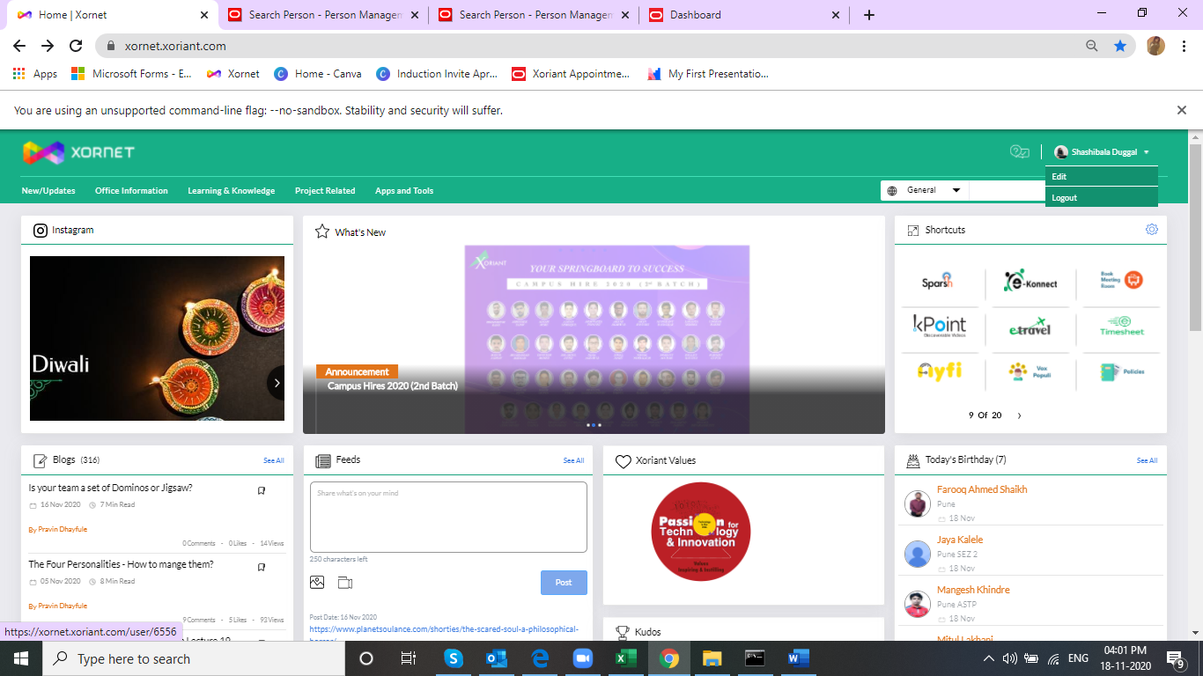

Step 3) Click on edit image option & add your image

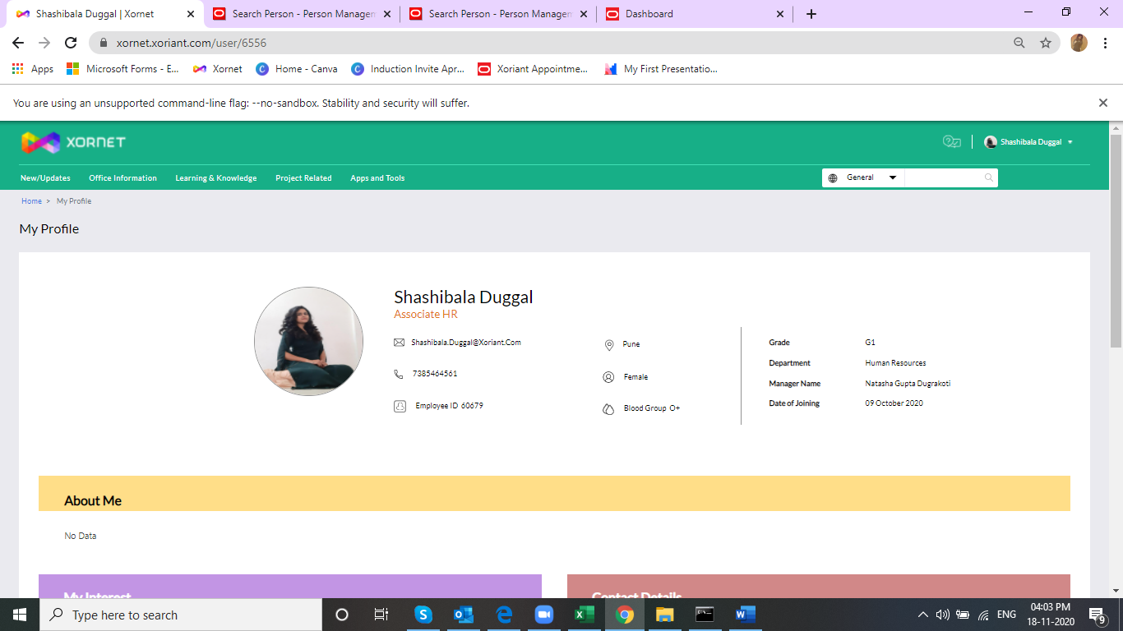

Step 4 ) Other information as per comfort level

